**Internet Security – COS80013 Lab - 4 Report**

**Student ID:** 104837257  
**Student Name:** Arun Ragavendhar Arunachalam Palaniyappan  
**Lab Name:** COS80013 Lab 5 – Network Reconnaissance and a Denial-of-service attack.  
**Lab Date:** 04 /04/2025  
**Tutor:** Yasas Akurudda Liyanage Don

Using nmap command to check the other Vms in the subnet

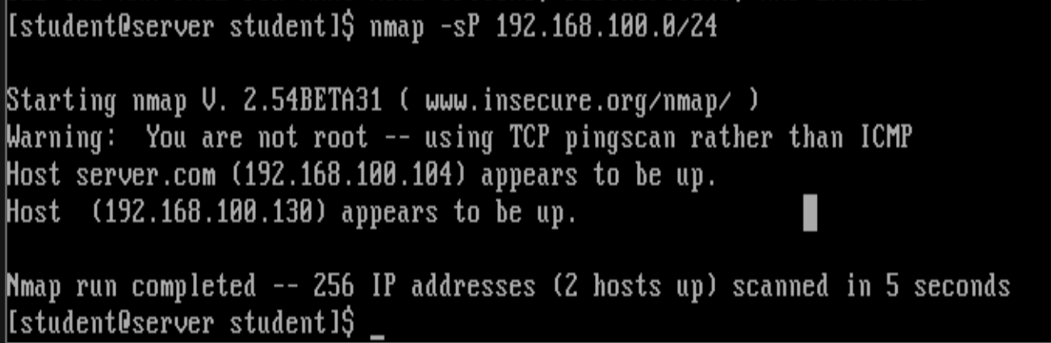



Back in **Wireshark**, scroll up and look for the start of a 3-way handshake (look for individual packets marked in green). There will be a SYN TCP packet, followed a bit later by a SYN ACK TCP packet. This is how ***nmap*** detects a responding host.





Protecting the windows VM against receiving ICMP pings from the linux box

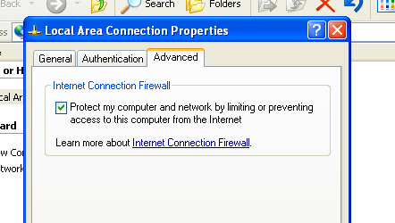

Linux box is now not able to ping the Windows VM

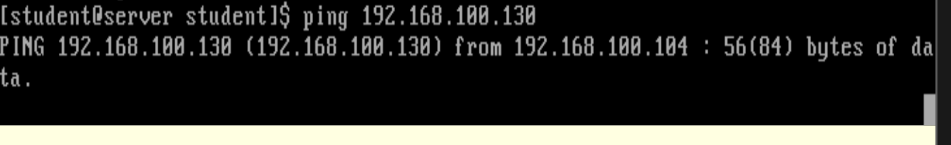

Trace route - The route from Linux to XP is only one hop – no intermediate routers.

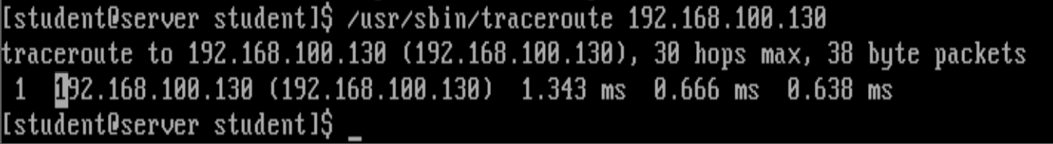

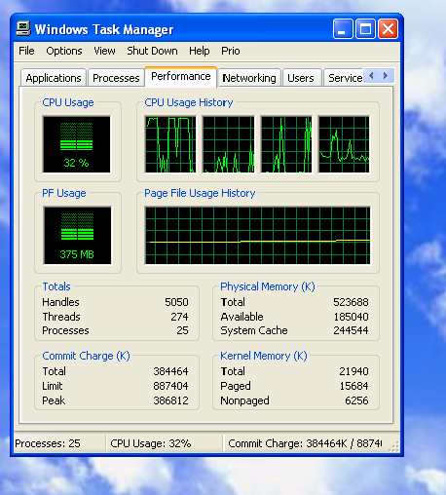



DDOS attack from linux box using the jol.c file to the windows machine and viewing the load shooting through from windows task manager